













**Submitted by,**

**Team-03**

**Name & ID:**

1. Tasnim Jannat Yeamoni (**211071015)**
2. Shahriar Islam (**211071019**)
3. Dilruba Islam (**211071012**)

**Course Name**: System Analysis and Design Lab

(CSE-2362)

**Batch:** 26th (**6th semester**)

**Department:** CSE

**Submitted to,**

**Dr. Md. Rabiul Islam**

Professor,

Department of Computer Science and Engineering,

Rajshahi University of Engineering & Technology, Bangladesh.



###### Table Of Content:

* **Team Information**

**Chapter1: Problem Identification 01**

* 1. **Introduction 01**
  2. **Problem Identification 07**
  3. **Conclusion 08**

**Chapter2: Project Planning 0****9**

* 1. **Introduction 0****9**
  2. **Work Breakdown Structure (WBS) 09**

**2.3 Gantt Chart 10**

**2.4 Conclusion 11**

**Chapter 3: Information Gathering & Analysis 12**

## Chapter1 Problem Identification

###### Introduction

Infinity Technology International Ltd is a leading ICT Company in Bangladesh and abroad. In

November 23rd, 1993, Infinity was founded by a group of graduates from USA, Australia,

Bangladesh and family members of renowned “Freedom fighters”.

INFINITY is thriving in Research & Development towards 4th Industrial Revolution and Beyond, Smart Geo Solution Design and Development, Banking & Fintech Solution, ICT Improvement, Cyber Security Esurance, Training, etc. Its major shareholders are from prominent business group like S. Alam Group. In addition, other shareholders are very familiar in this business doma

in. The organization has many alliances / partnerships with foreign renowned organizations like KOICA BD, GIE&S, Korean Expressway Corporation, S-Traffic, Winitech Co., KoROAD, Korean Transport Institute, ST Logic, KEPCO KDN, Trinion Inc., Neo information System, Oracle, Qualitype GmbH,

Eagle Ridge, Ducsan, Kaspersky etc.

As a fast-moving dynamic company, Infinity’s business focus is in Government Sector: Geo-Smart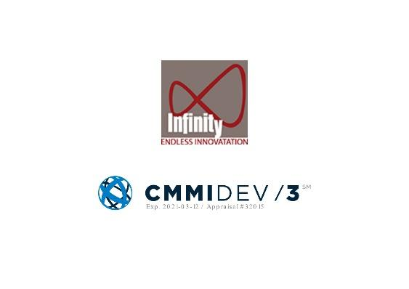

Solution, IoT, Education, Defense, ICT, Financial, Infrastructure, Training is foremost but not

limited. Subsequently, the organization has achieved numerous appreciations, certifications and

cheers from other clients and stakeholders.

Infinity aiming towards not only to meet the business requirements of clients but also can actually deliver beyond expectations as we have the capacity to invent and improvise to provide better solution. We are always ready for crafting new strategy to reach appropriate solutions to our clients’ pain points. Along the way, we integrate global best practices with unconventional ways of doing things to reach our goals. Our possible strategies presented allowed the client to assign weightage according to its needs and decide on a way forward to meet their business

requirements and growth.

During its development path, it has also earned substantial quality certifications from world-

renowned Credential Assessment Authority. Attainment of ISO 9001:2015 and CMMI Level 3 certifications are prime of them.

**Mission:** 21st-century Sof tware Defined Networking; team and customer engagement solutions that help you lead in a world of IOT, mobility, apps, social and cloud including  
Big Data Analytics and insight. ITIL's networking and engagement solutions can help enterprises re-engage in the digital space and build customer relationships, advocacy and lifetime value.

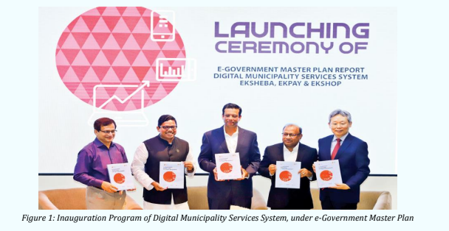

**Featured Products:**

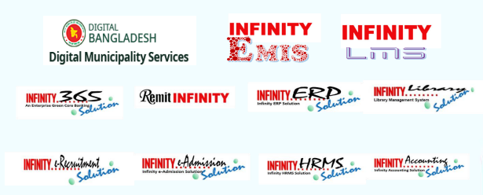

**Fig-1.2**

**Clients They Worked With:**

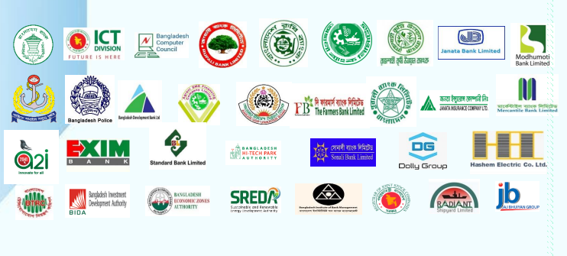

**Alliances and Partnerships:**

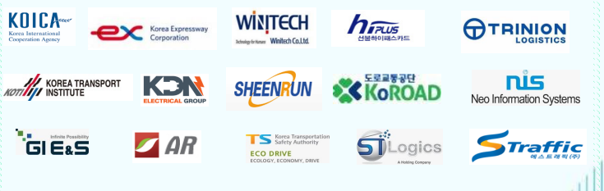

**Management structure of this company and it is given below:**

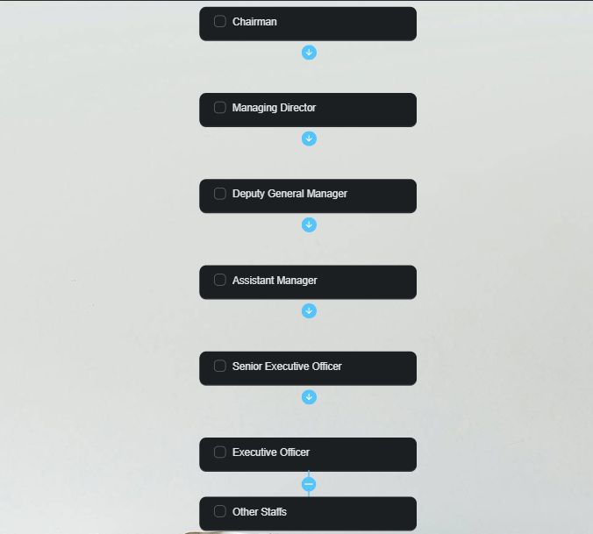



###### Problem Identification:

Problem analysis is a way of understanding the context within which you intend to work. It is a technique used to examine all the elements and factors that hinder an organization from achieving its objectives. The purpose of problem analysis is to reduce these constraints to the core problems and put aside the myriad details. We’re working to analyze the project named “Smart Driver’s License Project” of **Infinity Technology International Limited**.

**Problem -1:**

**Lack of better monitoring system**

This company need an automated management system to monitor their whole management system remotely.

**Problem -2:**

**Lack of sufficient information on the website.**

Website need to more upgrade for updating information related to company and their

running projects. We have found also some flaws need to be updated.

**Problem -3:**

**Lack of o**

**rganizational hierarchy**

Because there are few management layers, managers are often stretched thin, which can sometimes cause confusion among employees and lead to issues such as poor oversight and a lack of direction.

Need to Solve:

* Flatten Communication Hierarchy with Open Communication Channels
* Conduct proper selection

## Recognize employees how they want to be recognized

**Problem -4:**

**Lack of providing digital services**

There has no app of the project for managing their services properly.

Need to create a own application for managing digitally of this company.

**Problem -5:**

**No KPI (Key Performance Indicator)**

An example of a key performance indicator is, “**targeted new customers per month**”. Without KPL’s the staff will lose the encouraging because of missing a clear goal to be achieved, resulting A state of inaction at work. At the end of the day no one will say why the work was slow and less than production capacity because the capability already Unknown. Also decision-maker will not get a clear vision of the performance.

###### Conclusion

Problem analysis is the process of understanding real-world problems and user’s needs and proposing solutions to meet those needs. The goal of problem analysis is to gain a better understanding of the problem being solved before developing a solution. In this step, we tried to find out a number of problems of the project for analysis moving forward to the next stage of the system development cycle.

## Chapter2 Project Planning

## **2.1: Introduction:**

## A work breakdown structure (WBS) is **a project management tool that takes a step-by-step approach to complete large projects with several moving pieces**. Here, we break our project into small pieces for solving that problem easily. We find out some of the possible ways like store all the records electronically with a backup place or use of a company’s own good software instead of a record paper.

## **2.2: WORK BREAKDOWN STRUCTURE:**

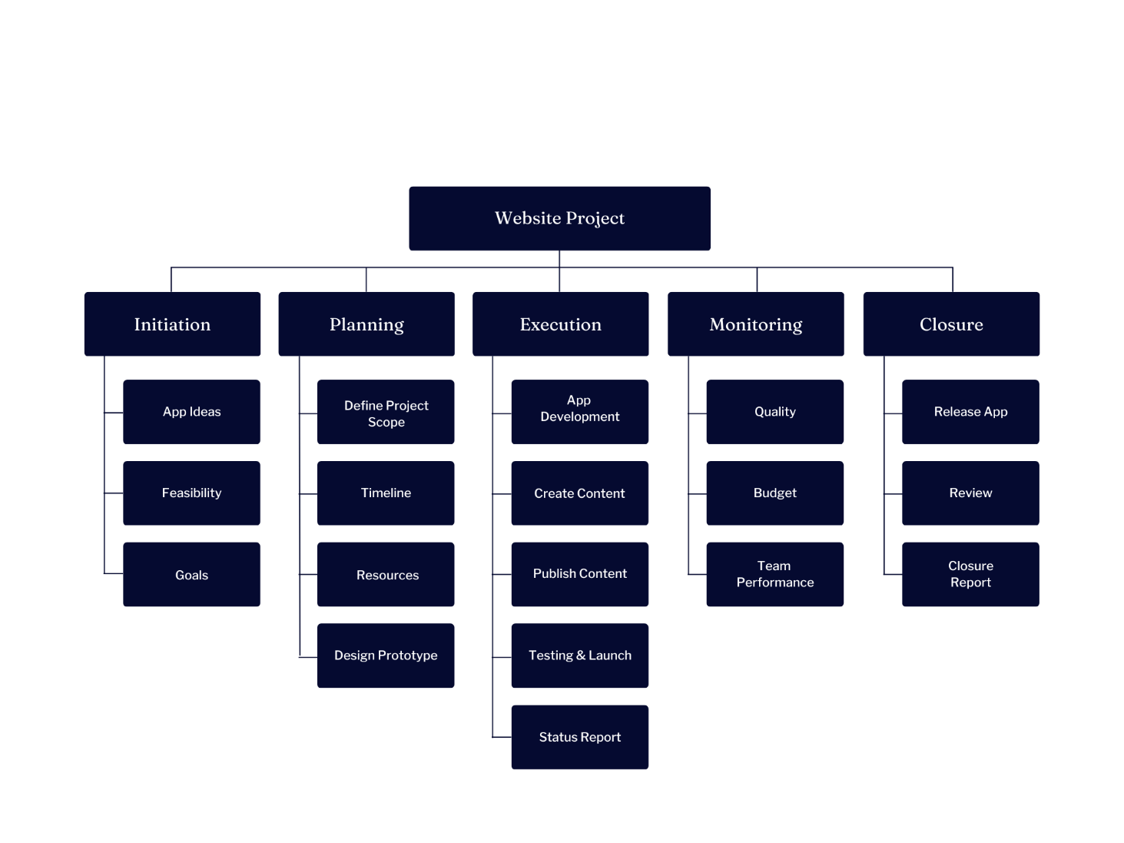

## **2.3: GANTT CHART:**

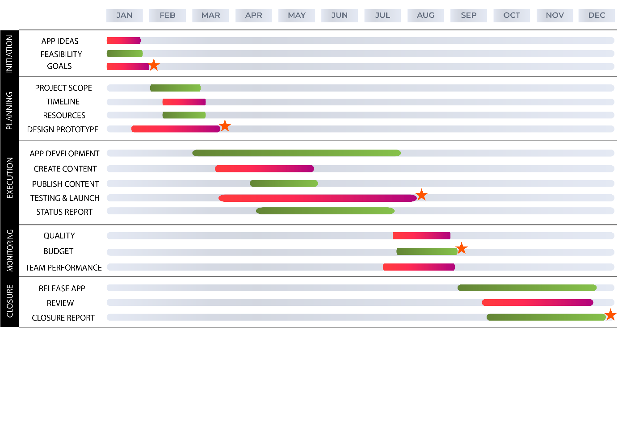

* **INITIATION:**
* **App Ideas:** Firstly, we will select what kind of app we want create for the

company.

* **Feasibility:** We need to research on Scheduling, Operational, Legal,

Economic, and Technical Feasibility to create this app.

* **Goals:** Have to set a primary goal.
* **PLANNING:**
* **Project Scope:** Determining and documenting details of the deliverable process.
* **Timeline:** Have to set a deadline for this project.
* **Resources:** Have to collect all the resources we need to work.
* **Design Prototype:** Have to discuss user needs, market challenges, have to

draw a primary sketch.

* **EXECUTION:**
* **App Development:** Need to contract with a team who are best at coding, app

developing.

* **Create Content:** Have to create conceptual content related to this company.
* **Publish Content:** Have to publish contents.
* **Testing & Launch:** After applying all the procedures like creating, developing,

publishing contents, it will be ready for tasting and

launching step.

* **Status Report:** Need to check the report with all of these steps we have worked

on it.

**M ONITORING:**

* **Quality:** Have to monitor the quality of the app development.
* **Budget:** Have to fixed budget and work on that for releasing the app.
* **Team Performance:** Have to monitor their daily performance to maintain the

work procedure sequentially.

* **CLOSURE:**
* **Release App:** Have to make available and deliver the app for the users.
* **Review:** Have to check user’s review.
* **Closure Report:** A Final report of this project.

###### 2.4 Conclusion:

###### In this Project planning, we tried to highlight in Gantt Chart applying the Work

###### Breakdown Structure (WBS) with all the detail what tasks will be accomplished, who

###### will be involved in completing the tasks, and when tasks should start and finish and how will be

###### the sequence.

## Chapter3

## Information Gathering & Analysis

## **3.1: Introduction:**

## Managing information involves gathering and distributing necessary information and assimilating them on the project management activities and processes. The information gathering techniques are repeated processes that are used to create and organize data across different kinds of sources.

## There are various kind of techniques to gather information about the company for analysis. Information can be gathered to Collect information with On-Site Observation, One-on-One Interview, Questionnaires and then will be analyzed with Data Flow Diagram (DFD).

## Need to know this kind of information:

## Information about the Organization

## Information about the User Staff

## Information about the Work Flow

## **3.2: Information Gathering Tools:**

## Information gathering methods/tools, are methods used by analysts to determine the needs of customers and users. Techniques that provide safety, utility, usability, learnability etc. for stakeholders result in their cooperation, commitment and sincerity.

## SAD-Information Gathering Tools - Best Online Tutorials | Source codes | Programming Languages

## **Fig: 3.1**

## **3.2: Review Literature, Procedures and Forms:**

Few system problems are difficult, therefore, as in the first step, a search of the literature through professionals; references and procedure manuals, company studies, government publications, or consultant studies is very useful. The primary drawback of this search is time. It is very difficult to such reports. Publications may be expensive and the information may be out dated due to a time lag in publication.

Procedures manuals and forms are very useful sources for the analyst. They describe the formation and functions of the present system. Up-to-date and good manuals save hours of information gathering time. Printed forms are widely used for capturing and providing information.

## 

## **3.3: On-Site Observation:**

## On site observation is the process of recognizing and noting people, objects and gets the information. The analyst's role is that of an information seeker who is expected to be detached from the system being observed. The role permits participation with the user staff openly and freely. The major objective of onsite observation is to get as close as possible to the real system being studied. For this reason, it is important that the analyst has the knowledge about the general make up and activities of the system. The following questions can provide the help in the onsite observations.

## **3.4: Interviews:**

* Sir, would you please describe the details of the company Infinity

Technology International Limited?

**Chairman:** Infinity Technology International Ltd is a leading ICT Company in

Bangladesh and abroad. In

November 23rd, 1993, Infinity was founded by a group of graduates from USA, Australia,

Bangladesh and family members of renowned “Freedom fighters”.

INFINITY is thriving in Research & Development towards 4th Industrial Revolution and Beyond, Smart Geo Solution Design and Development, Banking & Fintech Solution, ICT Improvement, Cyber Security Esurance, Training, etc. Its major shareholders are from prominent business group like S. Alam Group. Our mission is 21st-century Software Defined Networking; team and customer engagement solutions that help you lead in a world of IOT, mobility, apps, social and cloud including  
Big Data Analytics and insight. ITIL's networking and engagement solutions can help enterprises re-engage in the digital space and build customer relationships, advocacy and lifetime value.

* How did you manage the whole system of your organization?

**Managing Director:** Generally, I collect information, reviews, documentation from

assistant manager. Sometimes, I need to go on-site observation for proper observation.

* Sir, do you have professional website for this company?

**Managing Director:** Yes, we have but need to be upgraded.

* Sir, is this a profitable organization?

**Managing Director:** Yes, this is a profitable organization.

* Sir, do you have any application/software to organize properly in a digital way?

**Managing Director:** No, we haven’t any.

## **3.5: Questionnaires:**

Questionnaires can be conducted by mail, via telephone, through face-to-face point of contact interviews or in combination. Care must be taken to properly administer and track the results. Clear and concise instructions are required (no matter which method of collection is used) for there is no human interaction for clarification once the questionnaire reaches the customer. We need to collect data from administrator with proper techniques for bring continuity to improve in product quality, customer satisfaction, or service effectiveness. Questionnaires can be used to assess current system usability and technical performance.

Information lection **employee:**

* **What kind of pdate**

## **would yo u feel sho u ld be in the web site?**

* General info
* speciy________

## **3.6: Analyzing Section with DFD (Data Flow Diagram):**

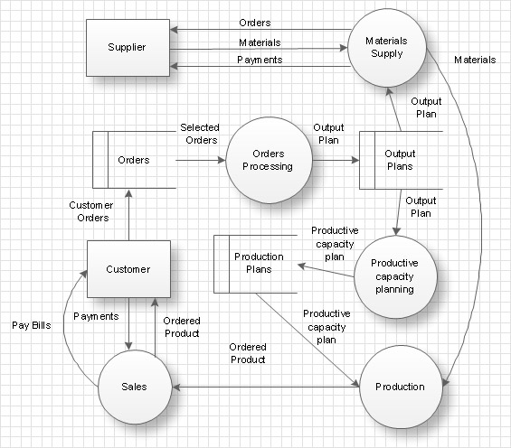

**NALYSING**